COCHIN UNIVERSITY OF SCIENCE AND TECHNOLOGY DEPARTMENT OF COMPUTER APPLICATIONS
KOCHI, KERALA, INDIA



MASTERS OF COMPUTER APPLICATIONS MAIN PROJECT
22-382-0401

AI DevOps Commander: An Autonomous DevOps Agent with GitHub Actions-Based Deployment Support

Company Name: Xcelcode Innovations
Submitted by: Prince Parmar Singh

ABSTRACT

Modern software delivery requires frequent deployments, yet DevOps workflows remain complex and error-prone due to manual steps, fragmented tooling, and inconsistent adherence to playbooks. This project presents AI DevOps Commander, a local-first DevOps automation system where users issue human-language commands (e.g., “Deploy v1.6 to staging and run tests”) through a web dashboard. A LangGraph-based interpreter converts instructions into a structured plan and enforces a mandatory plan preview + approval gate before any execution.

The system supports local deployments (Git/Docker/approved scripts only) and GitHub Actions–based deployments (workflow dispatch + run monitoring) using sandboxed adapters rather than unrestricted shell access. A watchdog agent evaluates logs, exit codes, and monitoring metrics (e.g., Prometheus) to detect failures and trigger policy-based rollback to a last-known-good version. A RAG layer validates plans against SOPs stored in a vector database (Chroma), improving operational correctness. The architecture combines a Next.js frontend with a FastAPI backend (Redis + RQ) and is designed to scale from SQLite to Postgres and from local execution to cloud/Kubernetes.

Problem Statement
Teams deploying software frequently face operational risk from manual and ad-hoc release procedures. Common issues include missed steps (e.g., tests not executed), unclear accountability, and weak auditability. Existing solutions often require significant setup, assume high DevOps maturity, or do not enforce a human approval gate for automated actions. In academic and small-team settings, these limitations can lead to unstable deployments and delayed releases.

Proposed Solution
AI DevOps Commander proposes a local-first DevOps command console that translates user intent into a structured deployment plan and enforces plan preview and approval prior to execution. The system is designed around safety policies, auditable logs, and a modular adapter layer to avoid unrestricted shell access.

Key Features
- Project registry (local path or repo URL) stored in SQLite
- Natural-language command parsing into a plan preview
- Mandatory approval step before enqueuing execution
- Background execution via Redis + RQ with log capture
- Web dashboard to create projects, generate plans, approve and view logs

Expected Impact
The expected impact is reduced deployment errors through enforced review gates, improved traceability via structured logs, and a clearer operational workflow for non- expert users.

System Architecture Overview
AI DevOps Commander follows a local-first client–server architecture with asynchronous execution. A web dashboard communicates with a backend API, which stores state in a database and uses a background worker to execute approved plans. Deployment can optionally target external platforms when configured.

Main Components
- Web Dashboard (UI): command input, plan preview, approvals, logs view
- Backend API: plan creation, approvals, execution status/log retrieval
- Database: projects, plans, executions, logs
- Queue + Worker: asynchronous plan execution
- Orchestrator / Deployer: dry-run by default; optional real deployments

Data Flow Diagram (DFD)
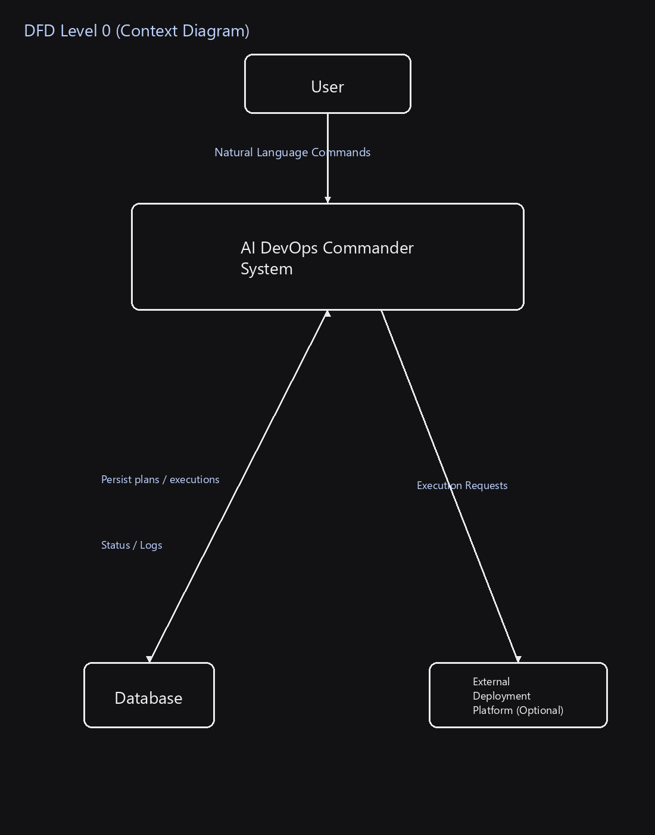
DFD Level 0 (Context Diagram)

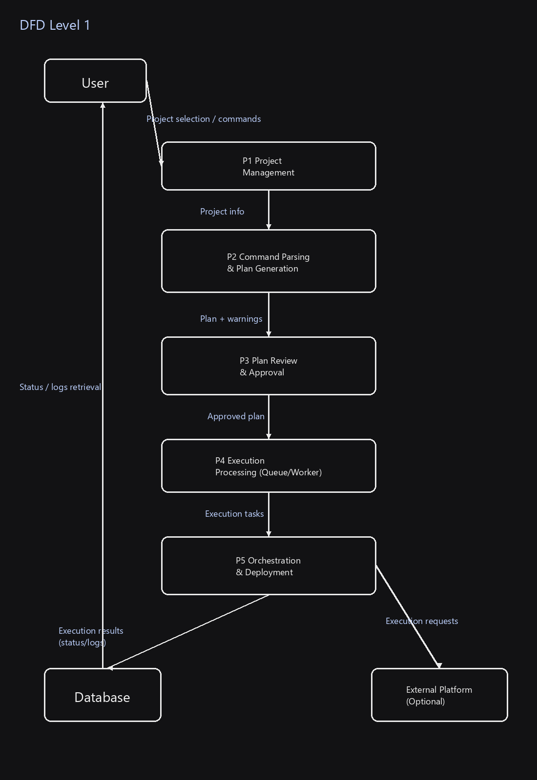
DFD Level 1

Tools and Technologies Used
Category Tool / Technology Purpose
Programming Languages Python Backend API, queue worker, orchestration logic
Programming Languages TypeScript Frontend UI and shared typings
Backend Framework FastAPI REST API endpoints
Frontend Framework Next.js + React Web dashboard for
command entry, plan preview, logs
Deployment Providers Vercel API / Render API Triggers cloud deployments
when configured
LLM OpenAI / Gemini Provider selection exists in settings; command parsing is currently deterministic
Container Docker Desktop For running Redis locally (per docs)

Queue Redis + RQ Executes approved plans

Current Implementation / Progress

Features Completed
- Backend health endpoint: GET /health
- Project registry: POST /projects and GET /projects
- Command parsing: POST /commands/parse (deterministic MVP)
- Plan preview warnings (MVP policy checks)
- Plan approval flow: POST /executions/approve/{plan_id} enqueues background job
- Execution status retrieval: GET /executions/{execution_id}
- SQLite persistence (projects, plans, executions)

- RQ worker implementation compatible with Windows
- Frontend dashboard: projects UI, command console, plan preview, live log view

Features In Progress
- Execution history listing in UI (History panel is mocked; backend listing endpoint not
present)
- Richer orchestration steps beyond dry-run logging
- Cloud deployment configuration hardening and end-to-end verification

Features Pending / Planned
- LLM-backed structured parsing (provider configuration exists; parser is currently rule- based)
- SOP/RAG validation using embeddings and a vector database
- Monitoring integration (Prometheus/Grafana documented; not implemented in current
code)
- Automated rollback logic
- Authentication/authorization
- Containerization assets and deployment automation (infra/docker is a placeholder)

Code Modules Implemented (Repository Mapping)
Backend (apps/backend/app):
- api/: routers for projects, commands, executions
- persistence/: SQLModel tables + repository functions
- queue/: Redis connection, RQ queue and worker, task entrypoint
- services/: command_interpreter (MVP), rag_advisor (stub), orchestrator, deployers
- common/: settings loader and structured logging

Frontend (apps/frontend):
- app/: main dashboard page
- components/: command console, projects panel, stat grid, live log view
- lib/: API client helpers, config, DTO types

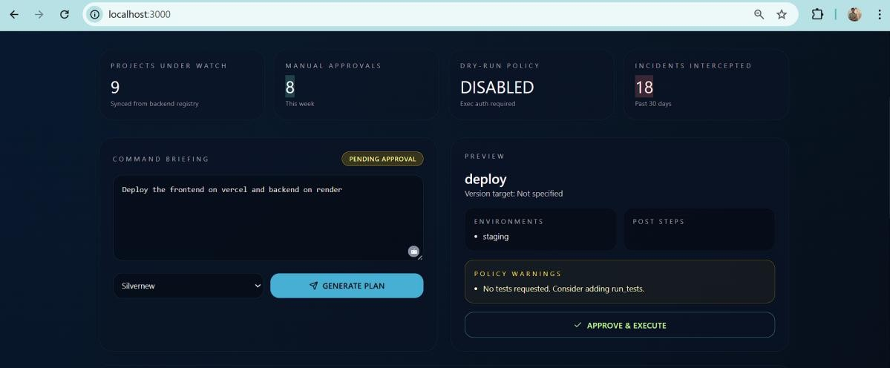
Latest Outputs

Current Working Features (Observable Outputs)
- Health check output: GET /health returns a JSON status payload.
- Plan generation output: POST /commands/parse returns a plan preview with action,
environments, post steps, warnings, and status=pending_approval.
- Execution output: approving a plan creates an execution and produces execution logs
(including DRY_RUN and provider details).

Future Scope
Planned enhancements based on repository documentation and current gaps include:
- Replace deterministic command parsing with an LLM-backed structured extractor behind the same API
- Implement SOP/playbook ingestion and vector search to generate policy warnings and
enforcement
- Add monitoring-based watchdog and policy-driven rollback workflows
- Expand orchestration steps and add execution history endpoints
- Improve scalability by migrating SQLite to Postgres and formalizing migrations

Conclusion
At the time of this first review, AI DevOps Commander has a functional MVP demonstrating the intended human-in-the-loop workflow: project onboarding, natural-language plan generation, approval gating, and background execution with log visibility via a web dashboard. Execution safety is emphasized through dry-run defaults and explicit enablement requirements for local execution. The project is ready for the next milestone: integrating an LLM-backed parser, implementing SOP/RAG validation, adding monitoring and rollback, and completing end-to-end deployment history and security controls.

